

**High Level Design**

Author: Team  
Creation Date: 2023-05-09

Last Updated by:   
Last Updated:

Revision: V1.0

Document Control

Information

|  |
| --- |
| File name |
| Building a CRM Application for Honda Showroom. |

Change Record

|  |  |  |  |
| --- | --- | --- | --- |
| Date | Author | Revision | Change Reference |
| 2023-05-09 | Anuja Gharewal | 1.0 | Initial version |
| 2023-05-09 | Nikita Uttarwar | 1.0 | Initial version |
| 2023-05-09 | Tejas Yeole | 1.0 | Initial version |
| 2023-05-09 | Divya Phursule | 1.0 | Initial version |
|  |  |  |  |

Internal and external Reviewers

|  |  |
| --- | --- |
| Name | Department |
|  |  |
|  |  |
|  |  |

Distribution

|  |  |  |
| --- | --- | --- |
| Copy No. | Name | Location |
|  |  |  |
|  |  |  |
|  |  |  |

Table of Contents

Document Control i

1 Introduction 1

1.1 Purpose 1

1.2 Definitions, Acronyms, and Abbreviations 1

1.3 References 1

1.4 Existing System 1

1.5 Proposed System 2

2 Modules 3

• Administration 3

• Inventory 3

• Order Processing 3

• Payroll Processing 3

• Payment 3

• Profit and Loss 3

• Reports 3

3 Functional Overview Real-Time Integrations 3

3.1 Administration 3

3.2 Inventory 3

3.3 Ordering Processing 3

3.4 Payroll Processing 4

3.5 Reports 4

4 High Level Design:- 5

4.1 DFD:- 5

4.1.1 0 level Data Flow Diagram :- 5

4.1.2 1 level Data Flow Diagram :- 6

4.1.3 2 level Data Flow Diagram:- 7

4.2 Data Flow Chart:- 8

4.3 Sequence Diagram:- 9

4.3.1 Sequcence Diagram For Lead:- 9

4.3.2 Sequcence Diagram For Product:- 10

4.3.3 Sequcence Diagram For Quotation:- 11

4.4 Use case Diagram:- 12

4.5 Activity Diagram:- 13

4.6 ER Diagram 13

5 Issues and Risks 13

6 Open and Closed Issues 14

6.1 Open Issues 14

6.2 Closed Issues 14

7 Appendix 14

# Introduction

Building a CRM Application for our esteemed client to process their business. Administration of an organization's offering exercises, promoting forms empowering organizations to dole out leads naturally and track open doors as they advance through the business pipeline towards conclusion dealing with their selling activities, marketing processes, track opportunities with large amounts of proficiency, dependability, and viability.

## Purpose

The project entitled “**Honda Showroom Management**” is to be developed for maintaining the show room activities like, customer maintenance, customer quotation generation, vehicle sales, customer dues maintaining for the instalment customers,  vehicle service and spare parts sales, Customer follow ups details, customer feedback form entry and employee details. The system is efficient in generating reports which will help in the maintenance of the showroom easily.

## Definitions, Acronyms, and Abbreviations

| Abbreviation | Description |
| --- | --- |
| HLD | High Level Design |
| LLD | Low Level Design |

Definitions

| Term | Definition |
| --- | --- |
|  |  |
|  |  |
|  |  |

## References

| # | Document | Author | Version |
| --- | --- | --- | --- |
|  |  |  |  |

## Existing System

The existing system is not automated fully as only the accounts are automated with the accounting software. The Customer follow-ups are maintained in excel which will take more time to search from the long lists, service details are not maintained through system so it is very difficult to maintain the details.  As the current data is maintained through ledgers and excel sheet so there is no proper reports for facilitation of the administration of the showroom.

**Disadvantages of the Existing System**

* Only accounts is systemized
* Lack of reports
* Vehicle Sales & Services are maintained in excel Sheet which leads to the inaccurate information.
* Customer data are not maintained properly which leads the follow-ups slow.

## Proposed System

The proposed system overcomes the disadvantages of the existing system and records the entire activities happening in the show room. The reports generated will enhance the efficiency of the application. The service registration alerts and completion are recorded which will be easy to maintain the service details.

**Advantages of the proposed System**

* Entire activities of the show room are recorded through the system.
* Customer Data is maintained.
* Reports generated will be more useful for management to take the quick business decisions.
* Customer database is maintained which will be helpful for intimating the service completion details and new offers
* Customer follow-ups are maintained which will be an added advantage of this system.

# Modules

## Administration

## Inventory

## Order Processing

## Payroll Processing

## Payment

## Profit and Loss

## Reports

# Functional Overview Real-Time Integrations

## Administration

## The administration module is used for registering the user details for accessing the system i.e. the login details are created in this module. The change password is used to change the existing password with new password.  The information about the vehicles available in the show rooms is recorded in the module.

## Inventory

## This module records the information about the purchase of vehicles and spare parts from the company based on the customer order and need for the spare parts for the service order. The stock of the spare parts and vehicles are maintained.This module also contains the information about the sales of the vehicle such as type of the vehicle, vehicle cost, customer information, mode of payment loan or cash and the bill is generated according to the vehicles and extra fittings purchased.This module also handles the sales of the spare part sales to the customers and generated the bill for the sales.

## Ordering Processing

This module records the complete customer information like the customer name, address, phone no, mobile number, type of the vehicle purchased. This module also handles the customer follow up activity i.e. if a customer comes and enquires about the vehicles sold in the showroom. This will be useful for the marketing team to follow up the customer and convert into the sale of new vehicle.

## Payroll Processing

This module handles the complete information of the employees and their salary details. The salary is divided into two types such as daily wages and monthly salary.

This module records the employee information like Employee name, address, phone no, mobile no, email, Date of Birth, Employee Salary Type like Monthly or Daily wages and Salary Details.

This module captures monthly or Daily Salary disbursement details of the employee.

## Reports

The various forms of reports such as employee information, salary report, stock reports for spare parts, sales report, purchase report, Customer Report, follow up report, Installment details of the customer and service details are available in this module.

# High Level Design:-

## DFD:-

### 0 level Data Flow Diagram :-

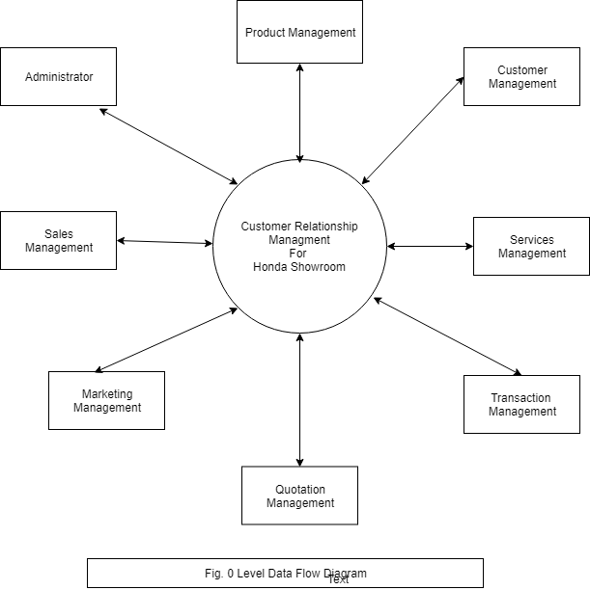

### 1 level Data Flow Diagram :-

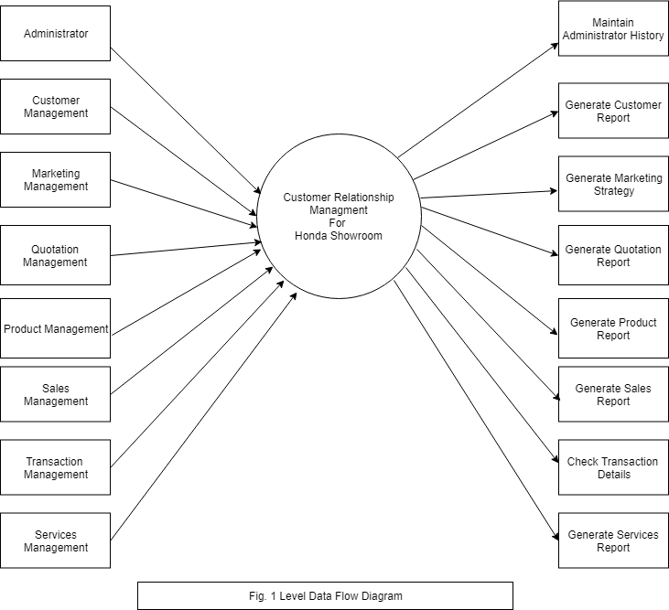

### 2 level Data Flow Diagram:-

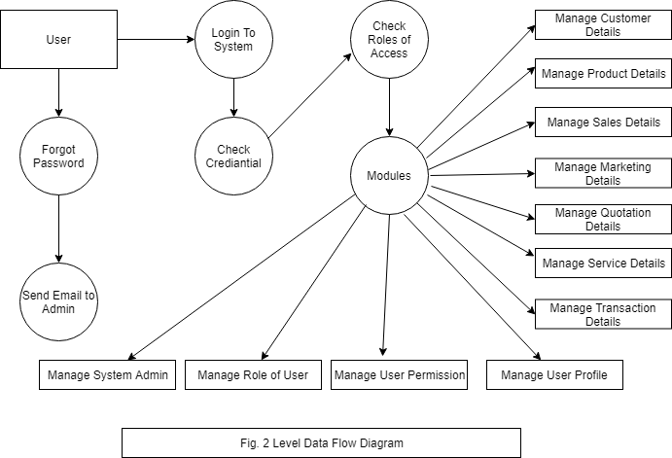

## Data Flow Chart:-

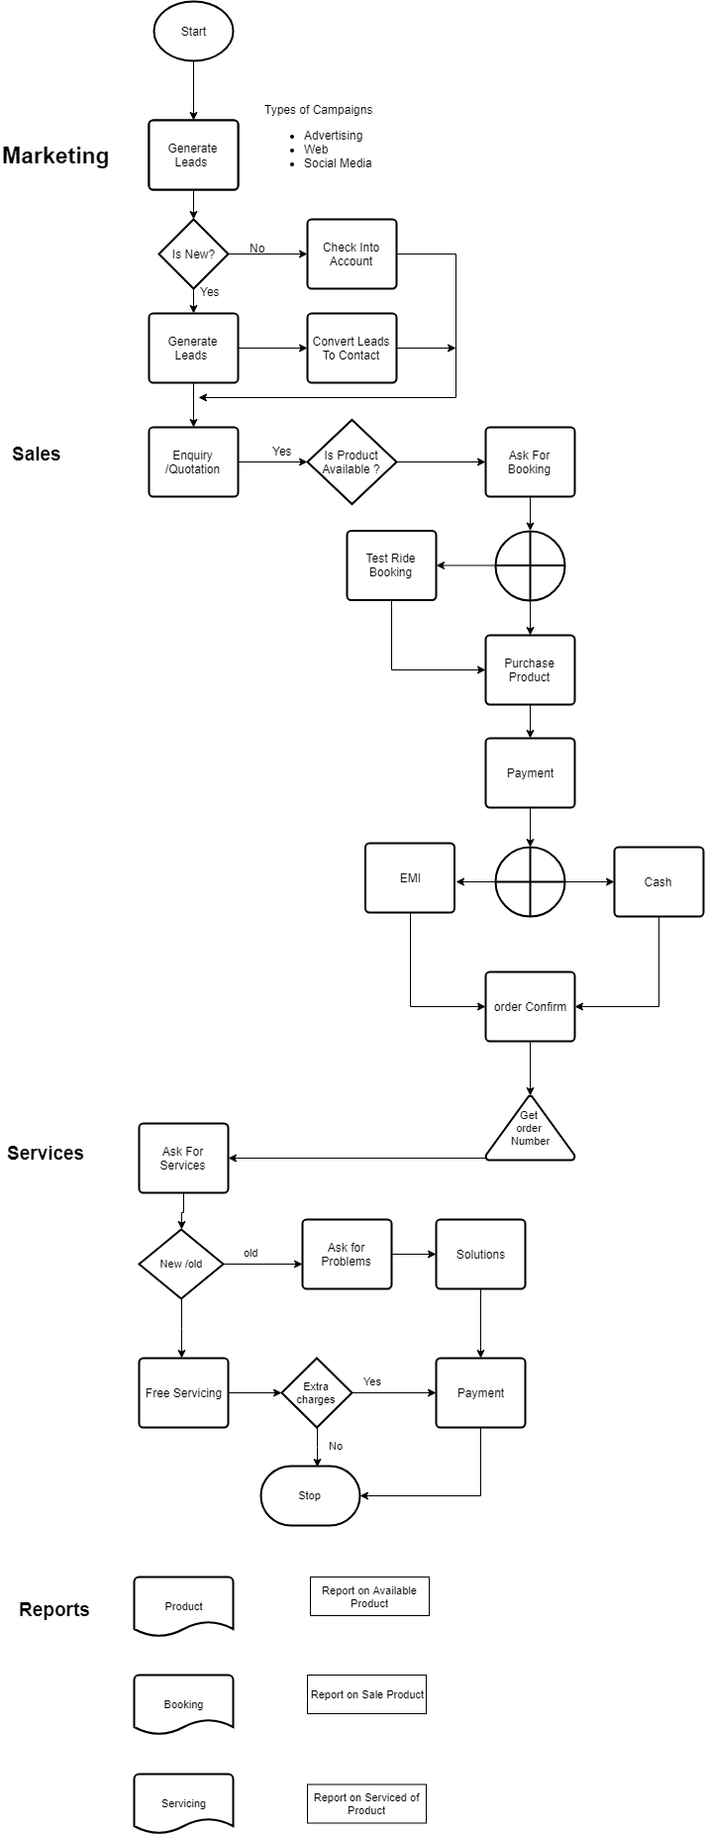

## Sequence Diagram:-

### Sequcence Diagram For Lead:-

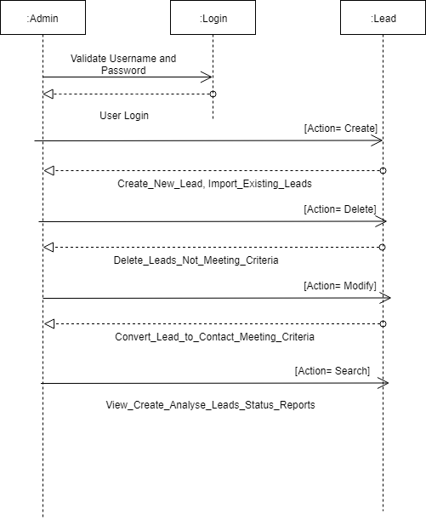

### Sequcence Diagram For Product:-

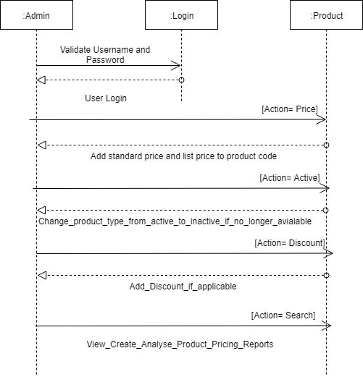

### Sequcence Diagram For Quotation:-

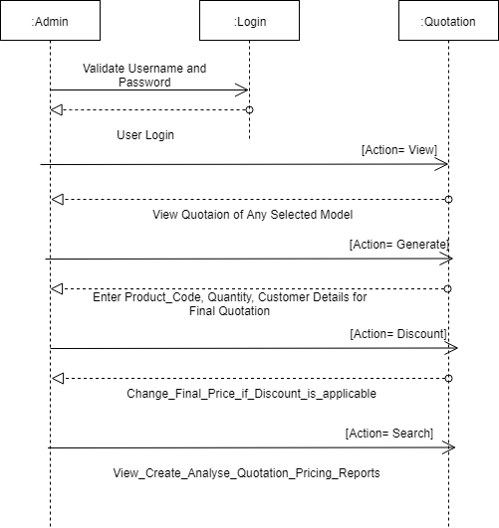

## Use case Diagram:-

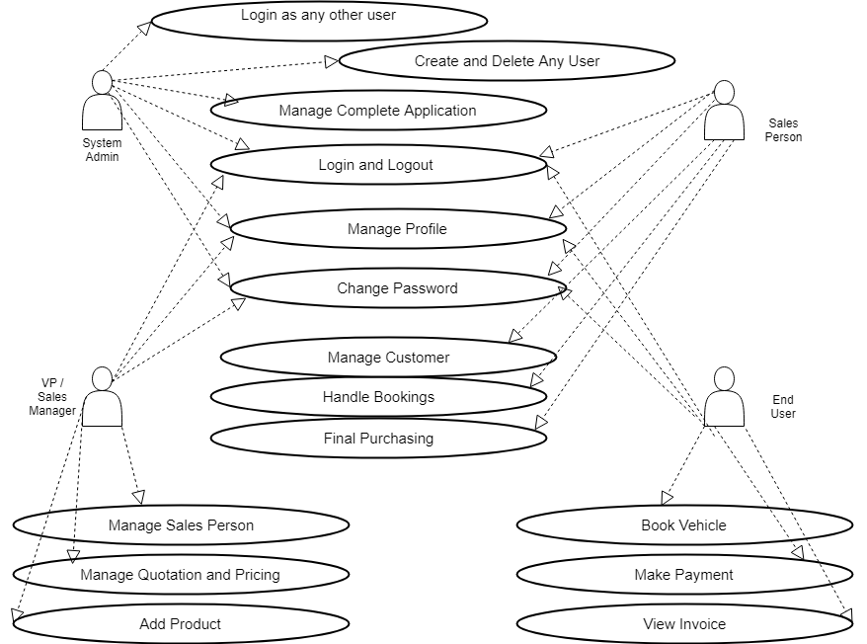

## Activity Diagram:-

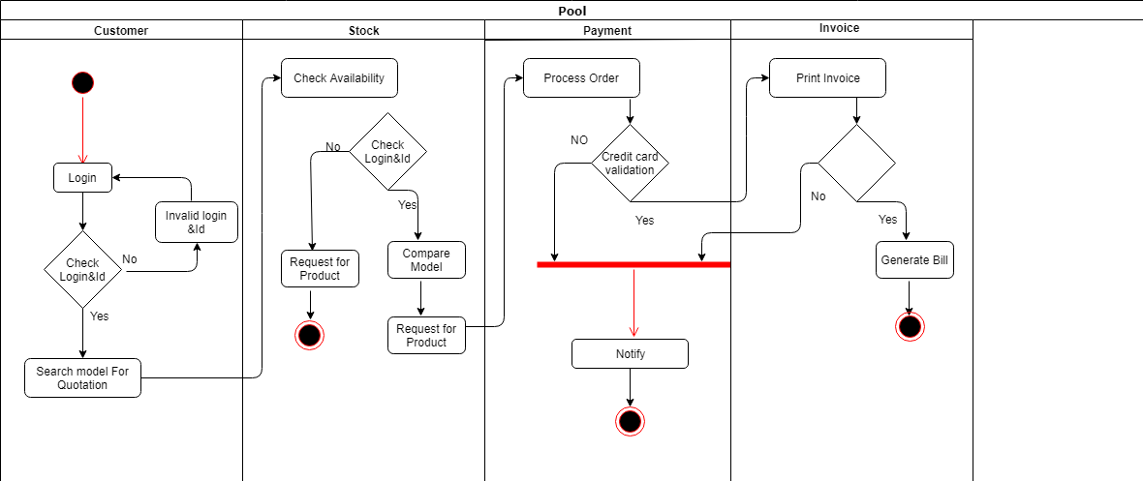

## ER Diagram

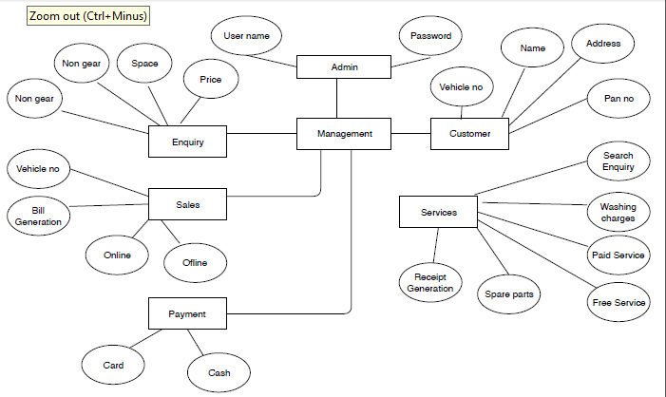

# Issues and Risks

[This section provides a complete list of all issues and risks]

| Issue/Risk | Description | Owner | Prio | Date |
| --- | --- | --- | --- | --- |
|  |  |  |  |  |
|  |  |  |  |  |

# Open and Closed Issues

## Open Issues

| ID | Issue | Resolution | Responsibility | Target Date | Impact Date |
| --- | --- | --- | --- | --- | --- |
|  |  |  |  |  |  |
|  |  |  |  |  |  |
|  |  |  |  |  |  |

## Closed Issues

| ID | Issue | Resolution | Responsibility | Target Date | Impact Date |
| --- | --- | --- | --- | --- | --- |
|  |  |  |  |  |  |
|  |  |  |  |  |  |
|  |  |  |  |  |  |

# Appendix